TASK -1
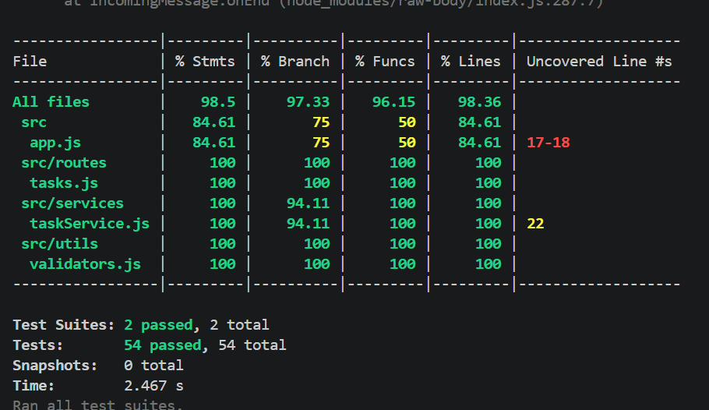

TASK-2
PART-A

These are the bugs I found while testing the API. Each one has a test in the tests/ folder. Bugs that are not fixed yet are marked with test.failing, so they still show up clearly without breaking the test run.

1. Page 1 skips the first tasks
Expected behavior: GET /tasks?page=1&limit=2 should give me the first two tasks.
What actually happens: It gives me the third and fourth tasks instead. The first page is never shown.
How I discovered it: I created five tasks and asked for page 1. I got the wrong ones back, so I looked at getPaginated in taskService.js and saw the offset was page * limit.
Fix: Change it to (page - 1) * limit so page 1 starts from the beginning. I fixed this one.

2. Status filter matches half words
Expected behavior: GET /tasks?status=do should return nothing, because "do" is not a valid status.
What actually happens: It returns both todo and done tasks.
How I discovered it: While reading getByStatus, I noticed it uses includes(), which checks if one string is inside another. I wrote a test with "do" to confirm it.
Fix: Use === so only an exact status matches.

3. Completing a task changes its priority
Expected behavior: Marking a high priority task as complete should only change its status and completion time.
What actually happens: The priority always becomes "medium".
How I discovered it: I completed a high priority task while testing manually and saw the priority had changed. Then I found priority: 'medium' written directly inside completeTask.
Fix: Remove that line so the task keeps its original priority.

4. PUT changes the task id
Expected behavior: Fields like id and createdAt are set by the server and should not change during an update.
What actually happens: If I send { "id": "hacked" } in a PUT request, the task's id really changes, and the task can't be found at its old URL anymore.
How I discovered it: The update function copies everything from the request body into the task, so I tested sending an id to see if it would be blocked. It wasn't.
Fix: Only allow the editable fields (title, description, status, priority, dueDate) to be updated and ignore everything else.

5. Broken JSON gives a server error
Expected behavior: If the request body is broken JSON, the API should return 400, since the mistake is on the client side.
What actually happens: It returns 500 Internal Server Error.
How I discovered it: I wrote a test sending bad JSON and expected a 400. The test failed, which is how I found this one. The error handler in app.js sends 500 for every error.
Fix: In the error handler, use the error's own status when it has one, so parsing errors return 400.

PART-B
I fixed Bug 1, where page 1 was skipping the first tasks. I picked it because anyone using pagination would lose the first page of data completely. In getPaginated, I changed the offset from page * limit to (page - 1) * limit, so page 1 now starts from the first task. The pagination tests were marked test.failing before, and now they are normal tests that pass. I also added one test to check that the last page returns the remaining tasks.

PART-C
I added PATCH /tasks/:id/assign, which takes { "assignee": "name" }, saves the name on the task and returns the updated task. If the task does not exist, it returns 404. For validation, the assignee must be a string that is not empty or only spaces, and not longer than 100 characters, otherwise it returns 400, because an empty name looks assigned but means nothing. I also trim extra spaces so " Priya " is saved as "Priya". If a task is already assigned, I allow reassigning and the new name replaces the old one, since in real teams work gets handed over often and blocking it would be annoying. New tasks now start with assignee: null so every task has the same shape. I followed the same route, validator and service pattern the other endpoints use, and wrote tests for the happy path, reassigning, trimming, the 404 case and all the 400 cases.

